The test is mostly done in CAPE sandbox. There are 2 done with VirusTotal Jujubox, since CAPE sandbox can’t always show all information (IP, files opened, and registry keys). The first screenshot is always from the original file and the second screenshot is always from the file we convert. The similarity score is calculated by ChatGPT. You can find the whole chat history from the link below:

<https://chatgpt.com/share/673c1762-6c84-800c-aa79-92d99ed77dcf>

1. 00b4c2ae2606b9547595f17468ed772097348d32 (CAPE sandbox)

IP:

Files open:



Registry keys: (The only difference is {EEEEE90E-F2CF-46E1-B8A4-9F65B29C46C4} and {F49E8DF0-3E1C-40F4-94CA-D25F14CF0EDB} for the last 4 keys.)



1. 0b734410c2d1b82f4a5d5d21d0d81e83d19adeae (CAPE sandbox)

IP:



Files open:



Registry keys:



1. 0e610d2980fa8fb5a1ef45d349af06241b081a3e (VirusTotal Jujubox)

IP:

  
Files open:



Registry keys: (The only difference is {5DA80E7B-D5EC-47E9-93B0-FF1DCE37CBF8} and {7759F6C7-5841-4355-BD7C-498C12728637} for the last 4 keys.)



1. 0f1fdb5b51858f602312b4ecc30623b2a16db8dd (VirusTotal Jujubox)

IP:



Files open:



Registry keys: (The only difference is {4307A404-D209-4CBA-838B-7950261364A7} and {9D60CEE8-2D8F-49E4-8FDC-11B00CBC9943} for the last 4 keys.)



1. 0fc60e049d68ee3978e12102d8c09a6f1486bc60 (CAPE sandbox)

IP:



Files open:



Registry keys:  


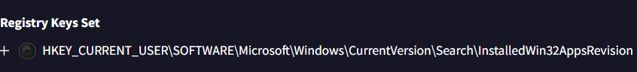



1. 1b5413aefc1325af9480c69498b69ab22c8dd292 (CAPE sandbox)

IP:



Files open:



Registry keys:

